Phase 2 — Requirement Analysis
Data Flow Diagram & User Stories
Field | Value
Date | 31 January 2026
Team ID | SWTID-2026-1543
Project Name | Virtual Agent–Driven SLA Breach Awareness & Justification System
Maximum Marks | 4 Marks

Data Flow Diagram
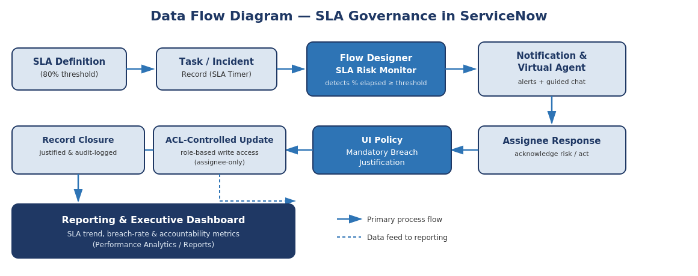
Figure 2.1 — Level 1 Data Flow: SLA Risk Detection to Governed Closure & Reporting
Data flows from SLA definitions and task/incident records into the Flow Designer SLA Risk Monitor, which evaluates elapsed percentage against the configured threshold. On breach risk, the flow branches into notification and Virtual Agent engagement; the assignee's response feeds UI Policy justification and ACL-controlled update; all closure and justification data feeds continuously into the Reporting & Executive Dashboard.

Data Dictionary (Key Fields)
Field | Table | Description
sla_percentage | task_sla | Percentage of SLA duration elapsed; monitored continuously by the SLA Risk Monitor flow
u_sla_risk_flag | incident / task | Boolean flag set to true when the configured threshold (e.g., 80%) is crossed
u_breach_justification | incident / task | Mandatory text field enforced by UI Policy once an SLA has breached
assigned_to | incident / task | Reference field used by ACLs to determine write access to governance fields
sys_audit | system table | Native ServiceNow audit table capturing all field-level change history for the record

User Stories
User Type | Functional Requirement (Epic) | User Story No. | User Story / Task | Acceptance Criteria | Priority | Release
Service Desk Agent (Assignee) | SLA Risk Detection | USN-1 | As an assignee, I want to be automatically notified when my ticket nears its SLA threshold, so I can act before it breaches | Notification is received within 2 minutes of crossing the threshold | High | Sprint-1
Service Desk Agent (Assignee) | Virtual Agent Governance | USN-2 | As an assignee, I want to acknowledge SLA risk via a guided chat, so I can quickly confirm awareness and select next steps | VA conversation completes and logs acknowledgement | High | Sprint-2
Service Desk Agent (Assignee) | Breach Justification | USN-3 | As an assignee, I want to be required to enter a justification when an SLA breaches, so accountability is enforced | Record cannot be closed without the justification field populated | High | Sprint-2
ServiceNow Admin | Access Control | USN-4 | As an admin, I want only assignees to edit SLA-critical fields, so unauthorized changes are prevented | Non-assignee edit attempts are blocked by ACL | High | Sprint-3
Service Desk Manager | Reporting & Dashboards | USN-5 | As a manager, I want a real-time dashboard of SLA trends and breach justifications, so I can monitor team accountability | Dashboard reflects new breach/justification events within 5 seconds | Medium | Sprint-3
Compliance Auditor | Audit Readiness | USN-6 | As an auditor, I want a read-only, timestamped record of every SLA risk acknowledgement and justification, so audits are self-service | All records are visible, timestamped, and non-editable to the auditor role | Medium | Sprint-3
Service Desk Agent (Assignee) | SLA Risk Detection | USN-7 | As an assignee, I want the risk threshold to be configurable per SLA definition, so alerts stay relevant to different ticket types | Admin can set distinct thresholds per SLA definition without code changes | Medium | Sprint-1
Service Desk Manager | Escalation | USN-8 | As a manager, I want to be notified if an assignee has not acknowledged an SLA-risk alert within a set time, so I can intervene | Escalation notification fires automatically if no VA acknowledgement within the configured window | Low | Sprint-3

